Crowdsourcing and social engagement: potential, power and freedom for libraries and users.

Author: Rose Holley – Digital Librarian, rholley@nla.gov.au
Published: 18 November 2009

The contents of this research paper and an accompanying PowerPoint presentation formed Rose Holley’s keynote address to the Pacific Rim Digital Library Alliance (PRDLA) annual meeting in Auckland, New Zealand on 18 November 2009.

Acknowledgements
I would like to acknowledge and thank the busy people who gave their time to me to discuss crowdsourcing techniques and social engagement ideas and strategies, and for giving me candid information on the lessons they had each learnt about their respective crowdsourcing projects. These were Kent Fitch (Lead System Architect, National Library of Australia), Juliet Sutherland (Manager, Distributed Proofreaders), Liam Wyatt (VP Wikipedia Australia), Erik Moeller (Deputy Director, Wikimedia Foundation), Mark Kelly (FamilySearch Support Manager Australia/PNG, FamilySearchIndexing), and Fiona Hooton (Manager, Picture Australia). I also relate here my own experiences as Manager of Australian Newspapers. The research to write this paper was undertaken in my own personal time and contains my own personal views on the future of crowdsourcing for libraries and archives. These views are not necessarily shared or endorsed by the National Library of Australia (my employer).

Abstract
The definition and purpose of crowdsourcing and social engagement with users is discussed with particular reference to the Australian Newspapers service http://newspapers.nla.gov.au, FamilySearch http://familysearchindexing.org, Wikipedia http://wikipedia.org, the Distributed Proofreaders http://www.pgdp.net, Galaxy Zoo http://www.galaxyzoo.org and The Guardian MP’s Expenses Scandal http://mps-expenses.guardian.co.uk. These services have harnessed thousands of digital volunteers who transcribe, create, enhance and correct text, images and archives. The successful strategies which motivated users to help, engage, and develop the outcomes will be examined. How can the lessons learnt be applied more broadly across the library and archive sector and what is the future potential? What are useful tips for crowdsourcing? Users no longer expect to be passive receivers of information and want to engage with data, each other and non-profit making organisations to help achieve what may seem to be impossible goals and targets. If libraries want to stay relevant and valued, offer high quality data and continue to have a significant social impact they must develop active engagement strategies and harness crowdsourcing techniques and partnerships to enhance their services. Can libraries respond to the shift in power and control of information and dare to give users something greater than power – freedom?

Keywords
Crowdsourcing, social engagement, web 2.0, text correction, digital libraries, digital volunteers, virtual volunteering, wisdom of crowds, citizen science.

Outline: Page Number
1. Introduction …………………………………………………………………….. 2
2. Examples of Crowdsourcing in Libraries …………………………………….. 3
3. Examples of Crowdsourcing that have relevance for Libraries …………… 4
4. Common Factors in the Crowdsourcing Examples ………………………… 8
5. Tips for crowdsourcing ………………………………………………………… 14
6. Power, Potential and Freedom for Libraries ………………………………… 24
7. Conclusion …………………………………………………………………........ 26
8. References ………………………………………………………………………. 27
1. Introduction
Crowdsourcing is a new term in our vocabulary. It does not yet have a clearly agreed definition, is not recognised by my spellchecker, and does not have widespread usage in the library world. Wikipedia provides a useful starting point to understand the term. An extract of their page from August 2009 said the following:
“Crowdsourcing is a neologism for the act of taking tasks traditionally performed by an employee or contractor and outsourcing it to a group (crowd) of people or community in the form of an open call. For example, the public may be invited to develop a new technology, carry out a design task, refine or carry out the steps of an algorithm, or help capture, systematize or analyze large amounts of data (citizen science). The term has become popular with business authors and journalists as shorthand for the trend of leveraging the mass collaboration enabled by Web 2.0 technologies to achieve business goals. The difference between crowdsourcing and ordinary outsourcing is that a task or problem is outsourced to an undefined public rather than a specific other body. In crowdsourcing the activity is initiated by a client and the work may be undertaken on an individual, as well as a group, basis. Crowdsourcing has potential to be a problem-solving mechanism for government and non-profit use.”
I want to expand this definition by clarifying my opinion on the difference between social engagement and crowdsourcing. Social engagement is about giving the public the ability to communicate with us and each other; to add value to existing library data by tagging, commenting, rating, reviewing, text correcting; and to create and upload content to add to our collections. This type of engagement is usually undertaken by individuals for themselves and their own purposes. Crowdsourcing usually uses social engagement techniques to help a group of people achieve a shared usually significant and large goal. The goal could be achieved by individuals using web 2.0 social engagement techniques, but bigger and more significant outcomes can be achieved more quickly by working collaboratively together as a group. Crowdsourcing also usually entails a greater level of effort, time and intellectual input from an individual than just socially engaging. For example correcting the text of a newspaper article, or transcribing a complete shipping record involves more input than quickly adding a tag to a photograph, or rating a book on a scale of 1-5. Crowdsourcing relies on sustained input from a group of people to work towards a common goal, whereas social engagement may be transitory, sporadic or done just once. Clay Shirky’s book ‘Here Comes Everybody’ contains some interesting examples of both types of activity that have been enabled by web 2.0 technologies.

It is my opinion that crowdsourcing is a good thing for libraries and archives to undertake because of the benefits it brings:
- Achieving goals the library would never have the time, financial or staff resource to achieve on its own.
- Achieving goals in a much faster timeframe than the library may be able to achieve if it worked on its own.
- Building new virtual communities and user groups.
- Actively involving and engaging the community with the library and its other users and collections.
- Utilising the knowledge, expertise and interest of the community.
- Improving the quality of data/resource (e.g. by text, or catalogue corrections), resulting in more accurate searching.
- Adding value to data (e.g. by addition of comments, tags, ratings, reviews).
- Making data discoverable in different ways for a more diverse audience (e.g. by tagging).
- Gaining first-hand insight on user desires and the answers to difficult questions by asking and then listening to the crowd.
- Demonstrating the value and relevance of the library in the community by the high level of public involvement.
- Strengthening and building trust and loyalty of the users to the library. Users do not feel taken advantage of because libraries are non-profit making.
- Encouraging a sense of public ownership and responsibility towards cultural heritage collections, through user’s contributions and collaborations.
Very little has been published on who digital volunteers are, what motivates them, and how they are rewarded or managed in crowdsourcing projects. In March 2009 I published my own research into the text correction activity by digital volunteers on the Australian Newspapers Digitisation Program (‘Many Hands Make Light Work’). This report generated a huge amount of positive interest in the international library community and resulted in contacts with several other crowdsourcing projects. I received a very small amount of negative comment when I spoke to a gathering of 26 European National Libraries in The Hague about the report, along the lines of ‘that wouldn’t happen here’, ‘this would only happen in an island nation’, ‘people are only interested in helping because its newspapers’. I therefore became very interested in whether the Australian Newspapers experience of crowdsourcing was in fact unique due to the place and material type or whether it was typical. This may help establish whether crowdsourcing was a viable option for other libraries and archives. I contacted by phone, e-mail and in person several other people involved in managing the crowdsourcing projects, to discuss the lessons they had learnt and to get more information about their volunteers to see if there were commonalities. Three key projects were Distributed Proofreaders, the Wikimedia Foundation and FamilySearchIndexing. I also checked the ‘about the project pages’ for other crowdsourcing projects such as the BBC and Galaxy Zoo, and followed up the Guardian crowdsourcing experiment.

To further understand the current application of crowdsourcing and its relevance to libraries and archives we can look at eight good examples. Only two are from libraries (both the National Library of Australia), since most libraries have not yet utilised crowdsourcing techniques. The other six have been chosen since they have a direct relevance for libraries and their techniques could easily be applied in a library or archive context.

I found that the Australian Newspapers was NOT unique. The experience of the National Library of Australia did match those of other crowdsourcing projects. This paper outlines the commonalities. It is my opinion that if the lessons different crowdsourcing project managers have learnt and the tips given here for crowdsourcing are applied, any crowdsourcing project that is ‘for the common good’ and run by a non-profit making organisation is likely to be successful.

2. Examples of Crowdsourcing in Libraries

Example 1: Australian Newspapers Digitisation Program, National Library of Australia: Text Correction

The Australian Newspapers Digitisation Program (ANDP) (http://www.nla.gov.au/ndp/) commenced in 2007. The Program is collaborative with every State and Territory Library in Australia being involved. The service supports the key objectives of the Australian Newspaper Plan (ANPlan) (http://www.nla.gov.au/anplan/) to enable communities to explore their rich newspaper heritage. The main outcome is a free online public service – Australian Newspapers (http://ndpbeta.nla.gov.au/ndp/del/home). The service was released to users by the National Library of Australia in August 2008 and has now been in operation for over a year. As at November 2009, the Program has delivered free online public access to over 830,000 newspaper pages containing 8.4 million articles. The public enhanced the data by correcting over 7 million lines of text and adding 200,000 tags and 4600 comments. Within the first 6 months an active text correcting community of 1300 people corrected 2 million lines of text, which rose to 6000+ people and 7 million lines of corrected text after 14 months. By mid 2011 the Program will have made available 4 million Australian newspaper pages dating from 1803-1954. Rose Holley, Manager of the Australian Newspapers service says “This is an innovative library project which is exposing data to the public for improvement. The public are very keen to help record 200 years of Australian history by text correction of historic Australian Newspapers”.

Example 2: Picture Australia, National Library of Australia: Creation and addition of images

Picture Australia http://www.pictureaustralia.org/ harvests digital images from over 50 cultural heritage institutions both in Australia and overseas that have Australian based content. Since January 2006 the public have been encouraged to add their own digital images to Picture Australia via a relationship set up with flickr. The public upload their images to flickr and tag them with ‘Picture Australia’ which triggers Picture Australia to find and download them into Picture Australia. Any of the contributing institutions can then request permission from public users to upload the public contributed pictures into their own collections, as well as them remaining visible in the central Picture Australia pool. By August 2009, 50,000 images had been contributed by the public to Picture Australia and institutions such as the State Library of South Australia, and the City of Sydney had added public images from the pool into their own digital collections. The Picture Australia team request specific types of images from the public to build the collection. Public contributors can communicate with each other and post comments on images via a flickr group. Fiona Hooton, Manager of Picture Australia said “As a partner of PictureAustralia, flickr is now an open door for individuals to help build the nation’s visual record”.

3. Examples of Crowdsourcing that have relevance for Libraries

Example 3: Family Search Indexing, Latter Day Saints: Text transcription of records

FamilySearchIndexing http://www.familysearch.org/eng/indexing/frameset_indexing.asp made available millions of handwritten digital images of births, deaths and marriages records for transcription by the public in August 2005. There are also the complete US census records, parish and church registers from around the world and other significant and large international records waiting to be transcribed. There are active projects for shipping passenger lists in New Zealand and Immigrants lists in Australia. The site is run by the Church of Latter Day Saints (LDS). Once a record has been transcribed it is included in the free online FamilySearch service, one of the most heavily used genealogy resources in the world. The service currently has over 160,000 volunteers transcribing records, most of whom are not LDS. Volunteers can choose regions, projects or types of records to transcribe. Most of the records cannot be OCR’d because they are handwritten. The home page of the site says “The key life events of billions of people are being preserved and shared through the efforts of people like you”.

Example 4: Distributed Proofreaders, Project Gutenberg: Creation of Ebooks

Distributed Proofreaders (DP) http://www.pgdp.net/c is a non-profit making organisation not linked with any Library or University institution. The volunteers aim to make public domain books and journal issues into freely available eBooks. DP was originally formed in 2000 to help process the books in Project Gutenberg. . Originally volunteers had to find, scan, OCR and mark up the books themselves page by page. However they can now get digital images of public domain books from the Internet Archive and Google Books so rarely have to complete the scanning stage. DP works under US Copyright law and has sister sites in Canada and Serbia. DP is one of, if not the earliest most forward thinking crowdsourcing project, and somehow it has gone largely unnoticed by the library sector even though the volunteers are digitising books. Juliet Sutherland the Manager of DP says “DP has a very strong sense of community and a shared goal to convert public domain books into e-books that are freely available. We grew up from grassroots and operate on a shoe-string budget of $2000 per year. It is a great achievement therefore to have 90,000 volunteers who have created and made publicly available 16,000 texts over the last 9 years. There is still a huge amount of material out there to be transcribed!”

Example 5: Wikipedia: Creation of digital encyclopaedia; improving personal names authority file at the German National Library; Wikisource.

There are several projects going on at the Wikimedia Foundation. The most well know is the free online encyclopaedia created by the public, Wikipedia. It has grown from 0 to around 10 million volunteers and 10 million articles in 250 different languages since 2001. The English version has 3 million articles and current opinion is that the encyclopaedia is now well established and practically finished. There is a well established pool of self managing volunteers working with clear guidelines and policies. Wikimedia is working hard to update its now outmoded, difficult and clunky volunteer software, recognising that this is critical to retaining volunteers. Andrew Lih says in the conclusion of his book (‘The Wikipedia Revolution’) “Wikipedia led the way in demonstrating that the collaborative accumulation of knowledge was not only feasible but desirable. Its neutrality policy, combined with a global team of volunteers helped make Wikipedia not just a clone of existing encyclopedias , but an encyclopedia that made recording human history a revolutionary, collaborative act.”

The cultural heritage sector of Australia has been formally asked by Wikimedia Australia if there are any partnerships they would like to develop where they could harness the Wikimedia volunteers. For example in 2005 the volunteers at Wikimedia Deutschland worked with the Deutsche Bibliothek (DDB) (German National Library) on a Personal Names Data Authority File project. The Personennamendatei (PND) has library datasets for more than 600,000 persons and contains more than 2 million names. Every record of the PND has a unique number that helps keep apart persons with identical names. Deutschland Wikipedia also has a person’s name file and 20% of the articles in the encyclopedia are for personal people. A project to enrich articles in the German Wikipedia with PND numbers and links back into the DDB's catalogue was arranged. There were benefits for both organisations since Wikipedia gained persistent and controlled links to literature from and about specific people and the DDB got thousands of corrections and updates to the PND by volunteers who checked and matched each Wikipedia authority file against the PND authority file. After 2 weeks 20,000 Wikipedia articles had links added to the PND. A Wikimedia article and a conference paper outline the project more fully. Another Wikimedia project, Wikisource, is transcribing public domain books into Ebooks.

Example 6: UK MPs Expenses Scandal, The Guardian: Tagging subject content of records/archives
In June 2009 a scandal was uncovered about UK MP’s expenses. This created huge public interest and outrage and the result was that 2 million documents relating to MP’s expenses were made publicly available as PDF’s. The Guardian newspaper built a website http://mps-expenses.guardian.co.uk/ in a matter of days that enabled the public to view, read and mark documents they felt should be exposed and investigated. Since the expenses were often handwritten (in mostly terrible handwriting that was barely legible) they could not be OCR’d. 170,000 documents were reviewed within the first 80 hours by 20,000 members of the public who could mark them as:

- Not interesting e.g. coversheet or stationary
- Interesting e.g. its significant expenses claim
- Interesting but known e.g. it’s a duckhouse
- Investigate this! I would like to know more! (i.e. find the scandals)
If interesting, they needed to transcribe the relevant details for follow up by the Guardian journalists. Much scandalous data was recovered and all sorts of interesting facts and figures. An article was published by the Guardian outlining the lessons learnt about crowdsourcing. This project has significant relevance for archives, manuscripts and records. No doubt the MP’s thought that the Guardian would never have enough journalists to trawl through 400,000 documents in illegible handwriting and so need not worry. They did not realise the public would do the job for them!
Example 7: Galaxy Zoo, International University Collaboration: Classification of digital photos
Galaxy Zoo http://www.galaxyzoo.org/ is an online collaborative astronomy project involving several international Universities. Members of the public are invited to assist in classifying millions of galaxies from digital photos. The site proved hugely popular very quickly and has 150,000 volunteers who have already classified 50 million galaxy images. The site is fun and very easy to use, and the topic of exploring our galaxy holds a perpetual fascination for many of us.
It is a good example of citizen science. Unexpected outcomes have occurred such as discovery of unknown objects, and the statistics and identifications have initiated entirely new research topics. Digital images of galaxies can only be correctly identified by the human eye so public help is needed to interpret the images. Without the volunteers it would take decades to identify all the galaxies. No knowledge of astronomy is required. Chris Lintott a member of the Galaxy Zoo team says, "One advantage [of helping] is that you get to see parts of space that have never been seen before. These images were taken by a robotic telescope and processed automatically, so the odds are that when you log on, that first galaxy you see will be one that no human has seen before". The current aim is to have "each and every galaxy classified by 30 separate users. The importance of multiple classifications is that it will enable us to build an accurate and reliable database, that will meet the high standards of the scientific community. For the first time, we'll be able to separate not only spirals from ellipticals, but obvious spirals from fainter, fuzzier things. No-one has ever been able to do this before.”
Example 8: World War 2 Peoples War, BBC: Creation of content

Between June 2003 and Jan 2006 the BBC asked the public to contribute their memories and artefacts of the Second World War to a website. 32,000 people registered to do this. The result is a website archive http://www.bbc.co.uk/ww2peopleswar of 47,000 stories and 15,000 images. This project has great relevance for libraries. The public are eager to supplement your content on various topics with both their knowledge and their own digitised content. Obviously the topic chosen was one in which many people had both first hand experience and knowledge, and memorabilia such as photographs of themselves in uniform and ration books. The site was revolutionary at the time because of the high level of social engagement and involvement it gave to the public, and the fact that many of the volunteers were elderly and had not used PC’s or the internet before. Many older people learnt valuable new IT literacy skills due to their desire to contribute. Libraries and other voluntary centres gave people free internet access in order to be able to join in with the activity. However, being run by the BBC meant there came a time when the project was ‘closed’ and all public interactions were stopped. The forums and communities developed over 3 years disappeared when their communication tools did. Part of the BBC website still has screenshots however of how the public used to interact and add content which is interesting to see. The website is now a static archive and the content is owned by the BBC, so the long-term future of the content is unknown.

The project history on the current website says:

“Members of the site could add stories and images to the site, and also take part in discussions on the site. These could take place in forums attached to stories or on the Help or Feedback pages. Members could 'bookmark' the pages of other site members in the My Friends section of their own Personal Pages. These might be users who had the same interests, who they enjoyed talking to on the site or other site helpers (online volunteers who undertook tasks such as greeting new members, helping researchers with their queries or encouraging new contributors to the site)”. These pages have now been removed from the website, but archived screenshots in the project history show how it worked.
Example 9: Mariners and Ships in Australian Waters: Transcribing shipping lists

This project to transcribe Australian shipping lists held in State Archives is run by volunteers; however the simple website http://mariners.records.nsw.gov.au/ for the volunteers is at least hosted by the State Records Authority of NSW. The volunteers all have an interest in shipping and genealogy and are transcribing the shipping records from the State Archives. Shipping records are of special interest to Australians because of their close links to convict records and movements. They contain handwritten lists of every passengers name and age and are crucial for Australian genealogists. The site has 600 volunteers to date.

Other Examples:

There are many other relevant examples including:

FreeUKGEN – (transcribing records)
Main site: http://freeukgen.rootsweb.com/
Projects: FreeBMD http://www.freebmd.org.uk/ (Births, Marriages, Deaths, UK) Established Jan 1999
FreeCEN http://www.freecen.org.uk/ (Census, UK)
FreeREG http://www.freereg.org.uk/ (Parish Registers, UK)

Information: http://freeukgen.rootsweb.com/UKgenFAQ.html

FreeBMD was the first FreeUKGen project. The searchable database became available in January 1999. The website says “Mocked at first as being ‘too big’, it has proved all its doubters wrong, as it moves towards its target of completing the indexes at a faster rate than even the early fans thought possible”.

WorldGenWeb Archives – (transcription of archives)
http://www.worldgenweb.org/index.php/worldgenweb-archives
Transcription of archive records from England, Canada, Brazil and Germany and many other countries and regions. For example Australia http://www.australiagenweb.org/ - Queensland list
http://www.worldgenweb.org/~ausqld/archives/index.htm

WorldGenWeb Project – (creation of country websites to genealogy resources, which drill down to states/regions and have transcription projects within)
http://www.worldgenweb.org/index.php/aboutwgw

The WorldGenWeb Project was created in 1996 in an effort to answer the growing needs of genealogists world-wide who were trying to research their ancestors online. The goal is to have every country in the world represented by an online website and hosted by researchers who either live in their own country or who are familiar with their country's resources.

4. Common Factors in the Crowdsourcing Examples

4. 1 Volunteer numbers and achievements

Wikipedia, Distributed Proofreaders and FamilySearchIndexing all released their services ‘quietly’ as did the Australian Newspapers with no or little advertising, but clear group goals. All had fewer than 4000 volunteers in their first year. These figures rose dramatically in subsequent years as the communities passed the word on and viral marketing (i.e. hearing of the project by blogs, forums, e-mail) took place. Currently Distributed Proofreaders, the Wikimedia Foundation and FamilySearchIndexing have been established for more than 4 years and all about 100,000 active volunteers. An active volunteer is defined as someone who works at least once a month on a regular basis. They all have far more registered volunteers, with FamilySearchIndexing reporting 160,000 volunteers in January 2009.

Fig. 1. FamilySearchIndexing – number of volunteers and achievements. Sourced from Mark Kelly.

Date | Number of volunteers | Cumulative achievements:  Number of individual names transcribed
August 2005 | FamilySearch Indexing on web introduced.
January 2006 | 2,004 online volunteers
January 2007 | 23,000 online volunteers | 102 million
January 2008 |  | 217 million
November 2009 | 160,000 online volunteers | 334 million

Fig. 2. Distributed Proofreaders – number of volunteers and achievements. Sourced from Juliet Sutherland.

Date | Number of volunteers | Cumulative achievements:  E-texts (books and journal issues) created
October 2000 | DP founded
January 2002 | 232 | ~ 60
2003 | 18,469 | 2,646
2004 | 29,029 | 5,912
2005 | 35,912 | 8,066
2006 | 51,098 | 9,842
2007 | 64,368 | 12,021
2008 | 78,015 | 14,440
End October 2009 (9 yrs since established) | 89,979* | 16,000 **

*cumulative registered users. Of these 3000 are active per month.
** approximately 2000 E-texts consistently produced per year.
Fig. 3. Wikipedia – number of volunteers and achievements. Sourced from http://en.wikipedia.org/wiki/Wikipedia:Statistics

Date | Number of volunteers | Cumulative achievements:  Articles created in English
January 2001 | Wikipedia created
Dec 2001 |  | 16,442
Dec 2002 |  | 100,000
Dec 2003 |  | 189,000
Dec 2004 |  | 445,000
Dec 2005 |  | 922,000
Dec 2006 |  | 1.5 million
Dec 2007 |  | 2.1 million
December 2008 (8 yrs since established) | 156,000 active monthly volunteers out of 10 million total* | 3 million (total of 10 million articles created in 250 languages)
* The number of registered volunteers has grown to millions. Most volunteers are not regular contributors, however. An unknown, but relatively large, number of unregistered contributors also contribute.
Fig. 4. Australian Newspapers – number of volunteers and achievements. Sourced from Rose Holley.

Date | Number of volunteers | Cumulative achievements:  Lines of text corrected in newspaper articles
August 2008 | Australian Newspapers released
August 2009 | 5,000+ | 4.7 million lines in 216,000 articles
November 2009 | *6,000+ | 7 million lines in 318,000 articles

*Unknown exactly how many volunteers there are since users do not have to register to correct text and users that are registered do not all correct text. This figure is a minimum estimate.

Fig. 5. Galaxy Zoo – number of volunteers and achievements. Sourced from Galaxy Zoo website.

Date | Number of volunteers | Cumulative achievements:  Classifications of images of galaxies
July 2007 | Galaxy Zoo released
August 2007 | 80,000 | 10 million
July 2008 | 150,000 | 50 million

Fig. 6. The Guardian MP Expenses Scandal – number of volunteers and achievements. Sourced from Simon Willison and Guardian website.

Date | Number of volunteers | Cumulative achievements:  Number of pages reviewed
June 2009 | Website released
First 80 hours | 20,000 | 170,000
November 2009 | 24,524 | 215,305

Fig. 7. Picture Australia – number of volunteers and achievements. Sourced from Fiona Hooton.

Date | Number of volunteers | Cumulative achievements:  Number of public images added to Picture Australia
January 2006 | Contribution of images by the public enabled.
January 2007 | unknown | 14,000 approx
January 2008 | unknown | 27,227
January 2009 | unknown | 42,774
October 2009 | 2,641 | 55,664

4.2 Volunteer Profile

Distributed Proofreaders, FamilySearchIndexing, Wikimedia Foundation and Australian Newspapers have independently undertaken their own analysis of volunteer makeup but have discovered the same things:

- Although there may be a lot of volunteers the majority of the work (up to 80% in some cases) is done by 10% of the users.
- The top 10% or ‘super’ volunteers consistently achieve significantly larger amounts of work than everyone else.
- The ‘super’ volunteers have long session durations and usually remain working on the project for years. They are working on your project as if it was a full-time job.
- Age of volunteers varies widely. The ‘super’ volunteers are likely to be a mix of retired people and young dynamic high achieving professionals with full-time jobs.
- Public moderator roles and roles with extra responsibilities are likely to be taken by volunteers aged 30-40 who are in full-time employment.
- Disabled, sick, terminally ill, and recovering people are among the volunteers since working at home is convenient, gives purpose and structure to the day, and gives feelings of value and reward. I was indescribably moved when I discovered one of the ‘super’ volunteers on the Australian Newspapers project had a terminal illness. She said helping gave a purpose to her remaining days and made her still feel useful now she had stopped work. It took her mind off her own situation for several hours each day.
- Many people find the time to do voluntary activities because they do not watch much television and as Clay Shirky describes it use this ‘cognitive surplus’ time for social endeavours.
- Half of the active volunteers are doing it because they are very personally interested in the subject matter, and half are doing it because they want to do some voluntary activities and see it as a good cause.
- Having a minimum level of computer/keyboard/internet knowledge is not a pre-requisite to volunteering. Many volunteers have low levels of PC proficiency and build up their levels of IT literacy by volunteering for online work. Having never used the internet or a computer before is not a blocker for many volunteers.
- Volunteers appreciate that they can learn new things as they go along and many of the projects could be termed as ‘educational’ in some respect.
- Many volunteers (especially genealogists) help on several different online projects.
- Volunteers are much more likely to help non-profit making organisations than commercial companies, because they do not want to feel that their work can be commercially exploited. (This places libraries and archives in a very good position for crowdsourcing.)
- Volunteers continue to work because they find it personally rewarding, and they want to help achieve the main group goal.
- The amount of work volunteers achieve usually exceeds the expectations of the site managers. The less that was expected of people the more they seemed to do.
- Some volunteers like to be able to choose subjects, and types of work they do, whilst others prefer to be directed to what to do next. Therefore most sites offered a ‘pick your work’ and a ‘do the next thing that needs doing’ option.
- Some volunteers like the idea of communicating with other volunteers, but some others just wanted to get on with the job. Generally volunteer moderators were keen communicators and ‘super’ volunteers were ‘head down’ types.
- On significant projects e.g. FamilySearchIndexing, Australian Newspapers, Galaxy Zoo, many volunteers describe the work as being ‘addictive’ or getting ‘hooked’ or ‘sucked in’ and time quickly escaping them, hence spending far longer than they actually intended to in voluntary work.

“I would like to say Australian Newspapers is a great initiative although I think there should be a warning about using this site and its possible addictive effects! I have a great deal of trouble getting back to what I should be doing at times.”
“When I first joined Galaxy Zoo 1 on 11th, July, 2007 my record longest continuous classifying period of time was 12 hours. I kept classifying when eating sandwiches as my lunch & dinner. It is deadly addictive.”

“While going through a whole month in a slightly obsessive crazed mind searching Australian Newspapers online, I just realised the kilos I’ve stacked on in just one month. I can’t seem to snap out of it; from dawn til dusk I seem to be in this website. Housework seems to have taken a backburner and meals are starting to come out of cans……..
Fig. 8. Profile of Super Text Correctors (Top 5) from the Australian Newspapers service.
 | Julie | Lyn and Maurice | Mick | Catherine | Fay
Interests | Family/local history | Family/local history; shipping | Family history/early Aust. history | Doing something to help other people | Family history research
Age and status | 31-45;  stay at home mum | 55-62  retired couple | 41-60  retired | 31-45  working full-time | 61-80  retired
Activity | 15-45 hours correcting per week | 15 hours per week | 12 hours per week | 15 house per week | Varies
Why do it? | Enjoys it. A great way to learn about history. A service to the community | Sick of doing housework! | It benefits me and other people | Want to do something useful; finds the content fascinating | Need something to do in my spare time. It benefits me and others and I enjoy the challenge
Will you continue? | Yes – a “must do” mission” | Yes – it helps us and other people | Not sure | Yes | Yes
What would keep you motivated? | More papers added | Working on specific projects/topics | More papers added | Being given ideas on topics to correct | ?

4.3 Motivational factors

Quotes from volunteers:

“Why do I spend 6 hours a day on Galaxy Zoo? Simply because it gives people who are not lucky enough to be a part of the scientific community a chance to take part in something that furthers the understanding of not only Galaxy's but our future as well. I’m just loving my time here.”

“Why do I spend 8 hours a day on Australian Newspapers? The Australian Newspapers digitisation program is the best thing that has ever happened to me in twenty years of family history research. It is a wonderful resource and so valuable for folk who can only do research on-line. Correcting electronically translated text is a worthwhile and enjoyable task and I am happily correcting text to help record Australian history.”

John Jorgensen gives a good list of 21 general motivating factors in his blog. The factors that motivate digital volunteers are really no different to factors that motivate anyone to do anything:

- I love it (As Clay Shirky would say ‘The internet runs on love’).
- It is interesting and fun and I learn new things.
- It is a worthy cause.
- I want to volunteer and give something back to the community.
- I can help in achieving the group goal.
- The goal/problem is so big it is a challenge.
- I am playing an important role in the field of science or history and helping to record, find or discover new things.
- You placed your trust in me and I want to prove I can do it even better than you thought.

By observation and questioning, site managers reported that volunteers were generally highly self motivated but there were a few things that noticeably increased their motivation:

- Adding more content more regularly to the site for them to work on.
- Raising the bar and increasing the challenge/end goal e.g. identify all the galaxies in the universe; correct all the text in all newspapers; digitise every out of copyright book.
- Creating an online environment of camaraderie for the virtual community by use of forums so that the digital volunteers feel part of a team and can give each other support and help.
- Being very clear about what, how and when things should be done (instructions, FAQ, policies).
- Acknowledgement of the digital volunteers in various ways.
- Rewarding high achieving digital volunteers.
- Being able to see the progress of the big goal and their place in that (by transparent statistics).

4.4 Types of acknowledgement and reward offered

Many of the sites were unable or had not thought to offer any acknowledgement or reward to volunteers. Being non-profit making organisations, most were limited in the type of reward or acknowledgement they could offer anyway. In all cases digital volunteers were proving to do great work without reward systems and had volunteered on the basis there would be no reward. However some of the sites were now thinking about this more and the following ideas that cost little or nothing but worked had been used:

- Acknowledging by naming volunteers (or their handles) on web pages, in newsletters, publicity, on the item they created/amended.
- Volunteers being able to choose public or private profiles so they can be visible if they want.
- Rewarding high achievers in ranking tables.
- Certificates of achievement.
- Promotional gifts e.g. T-shirts, Books, vouchers.
- Travel to meet the paid staff on the project.

4.5 Management of volunteers

Most of the examples had either no paid staff or very limited staffing to manage and co-ordinate hundreds and thousands of volunteers. Because of this they had done two things:

- Utilised volunteers to moderate/co-ordinate other volunteers and to answer other volunteers questions.
- Implemented IT savvy ways through open source software to manage crowds, communications and processes e.g. forum and wiki software.

The main task of the paid staff in regard to management of volunteers was to create, establish or endorse guidelines, FAQ and policies for the digital volunteer processes. The site manager may also keep an eye on the forum activity and spot anything which may become an issue and resolve it through FAQ, policy or guidelines.

All site managers agreed this was the way to handle large online communities. No attempt should be made to seek paid staff to ‘manage’ digital volunteers. Erik Moeller at Wikimedia Foundation totally endorsed this viewpoint, and they have 10 million registered volunteers.

5. Tips for crowdsourcing

After talking to other crowdsourcing site managers and asking them all the same question “what lessons have you learnt?” and taking our own experiences into account I am able to come up with a combined, comprehensive list for librarians of tips for crowdsourcing. No site I looked at had utilised all the tips, so if a new site did I have no doubt they would be very successful. The tips are summarised with example screenshots where appropriate.

Fig. 9. Rose Holley’s checklist for crowdsourcing.

The Thing | The System | The People | The Content
- Clear goal  - Big challenge  - Progress  - Results | - Easy and Fun  - Reliable and quick  - Intuitive  - Options | - Acknowledge  - Reward  - Team support  - Trust | - Interesting  - New  - Lots  - History/Science

- Tip 1: Have a transparent and clear goal on your home page (which MUST be a BIG challenge).
You might know what you want to do, but you must tell your volunteers this as well and keep the message clear and prominent. It helps if your goal is massive and appears to be unachievable, or if you keep upping the size of your goal or the task.

Fig. 10. Goal - Family Search Index.

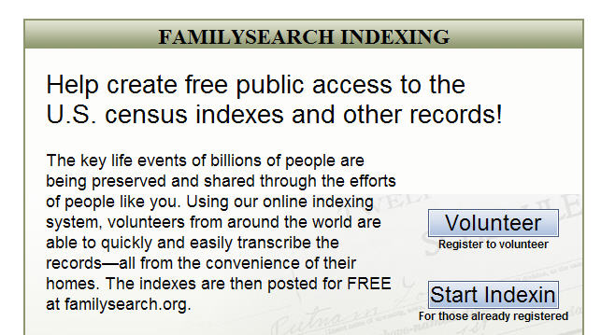

Fig. 11. Goal - Australian Newspapers.

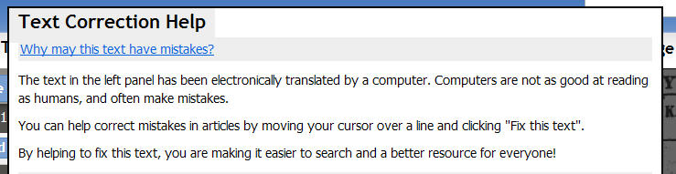

Fig. 12. Goal - Galaxy Zoo.



- Tip 2: Have a transparent and visible chart of progress towards your goal.
Simon Willison of the Guardian says “Any time that you’re trying to get people to give you stuff, to do stuff for you, the most important thing is that people know that what they’re doing is having an effect. It’s kind of a fundamental tenet of social software. … If you’re not giving people the ‘I rock’ vibe, you’re not getting people to stick around.” You must let volunteers know how well they are doing to keep their motivation up.

Fig. 13. Progress - The Guardian MP’s expenses – home page.
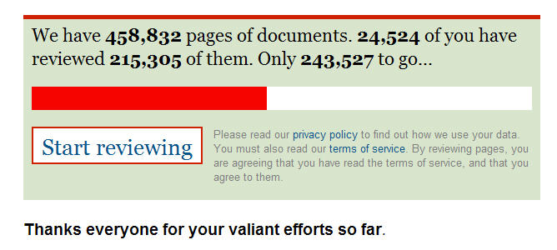
Fig. 14. Progress - The Guardian MP Expenses – MP page.
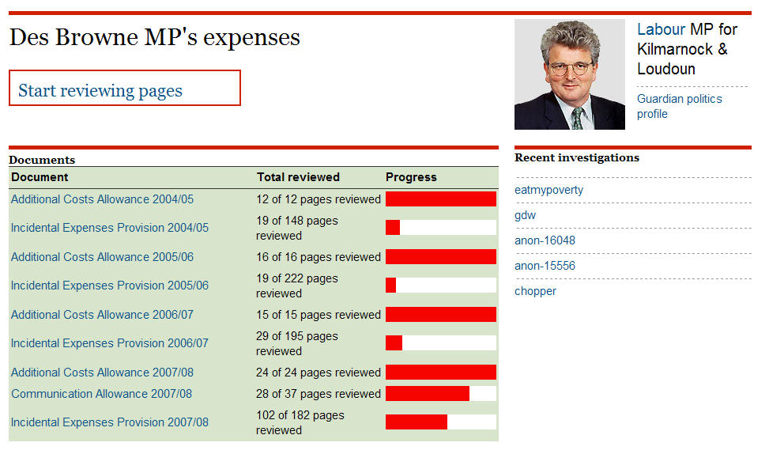
Fig. 15. Progress – the Distributed Proofreaders.
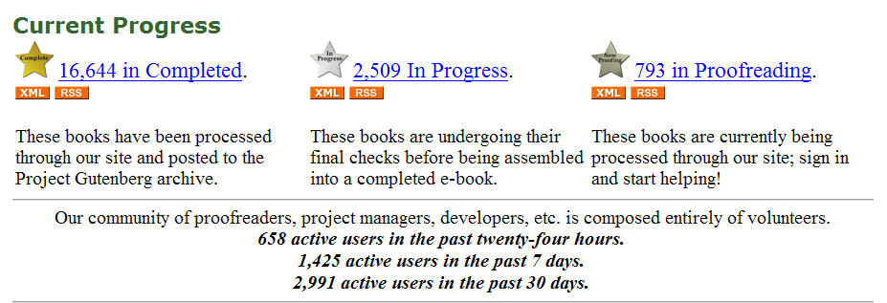
Fig. 16. Progress – Wikipedia.

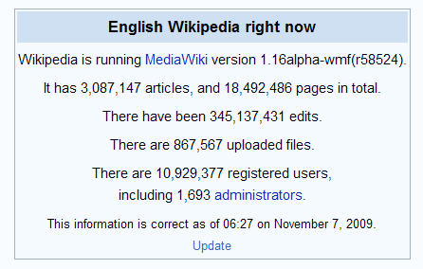

Fig. 17. Progress – Galaxy Zoo.

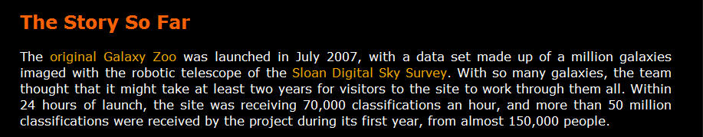

- Tip 3: Make the overall environment easy to use, intuitive, quick and reliable.
The usability of your system is really important. If you haven’t done usability testing beforehand then solicit and act on user feedback as you develop the system. In projects where volunteers numbers soared at a much faster rate than expected it was sometimes hard to do adequate load testing, but speed and reliability of the system is very important to users. They will drop off as quickly as they came if the system fails them in this respect. Simon Willison of the Guardian said “We kind of load-tested it with our real audience, which guarantees that it’s going to work eventually.” Wikipedia noted in their statistics “The big slowdown in the rate of article creation in June–July 2002 was caused by major server performance problems, remedied by extensive work on the software”. Make it as easy as possible for users to do work and options for this include no requirement to login (e.g. Australian Newspapers), very simple sign up process, easy login method.

Fig. 18. Easy and Quick to use – Australian Newspapers no login required.
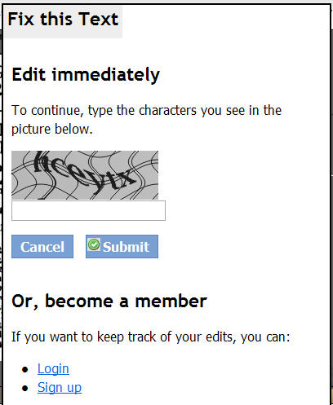

- Tip 4: Make the activity easy and fun.
Make it like a game and keep it light hearted. After all the volunteers are doing this for nothing. The easier and more fun it is the more likely they are to join in and keep doing it.

Fig. 19. Easy and Fun – The Guardian MP’s expenses.

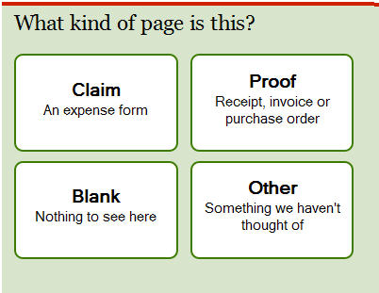 | 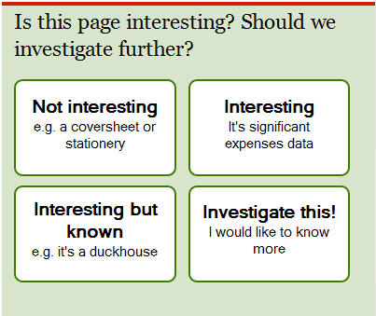

Fig. 20 Easy and Fun – Galaxy Zoo.

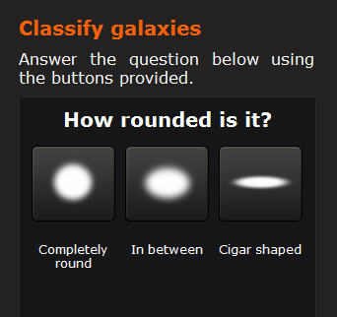 | 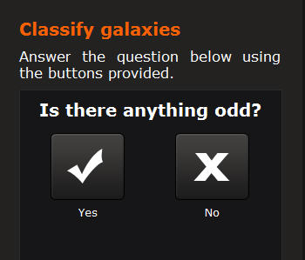

Fig. 21. Easy and Fun- Australian Newspapers.

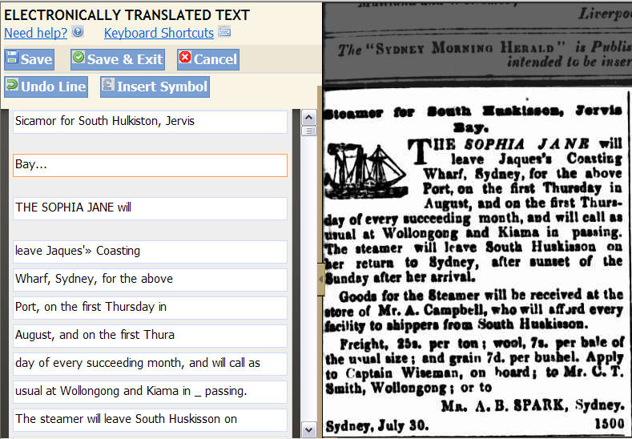

- Tip 5: It must be interesting.
Something about the content must be really interesting. Regular drawcards are history, science, personal lives, scandals, genealogy, and animals.

- Tip 6: Make the results/outcome of your work transparent and visible.
Some interesting results (aside from achieving your main goal) may come out of the work and it is important to share these with the volunteers as soon as you find them, because if it wasn’t for them it would never have happened. They are especially interested in new discoveries and research arising out of what they have done.

Fig. 22. Results – Galaxy Zoo.

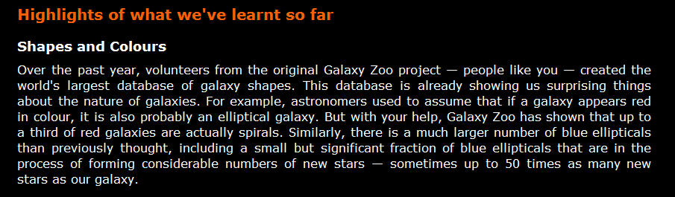
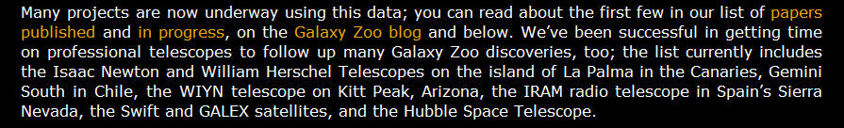

Fig. 23. Results – Distributed Proofreaders.
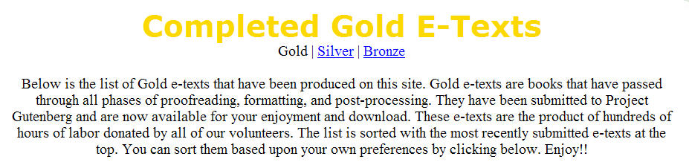

Fig. 24. Results – The Guardian’s MP’s expenses.

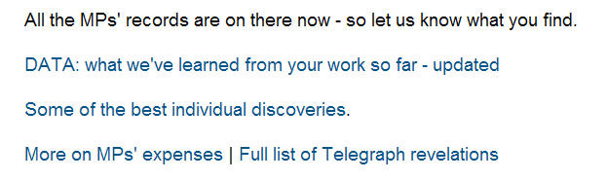

Fig. 25. Results – BBC People’s WorldWar2.
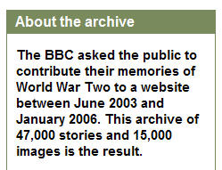

- Tip 7: Reward high achievers by having ranking tables and encourage competition.
Putting in ranking table is easy and costs nothing, yet it makes a big difference to your volunteers and helps to motivate them.

Fig. 26. Reward – Australian Newspapers.

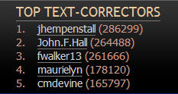

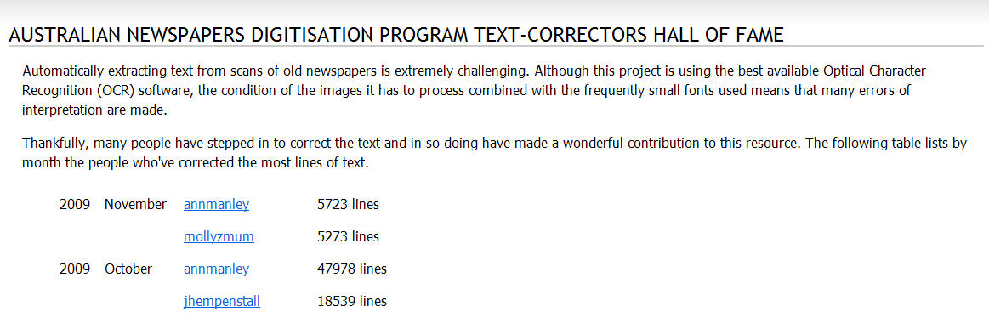

Fig. 27. Reward – Guardian’s Expenses.
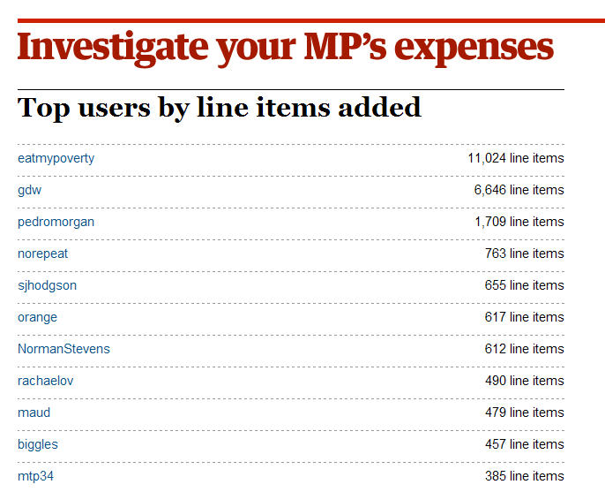

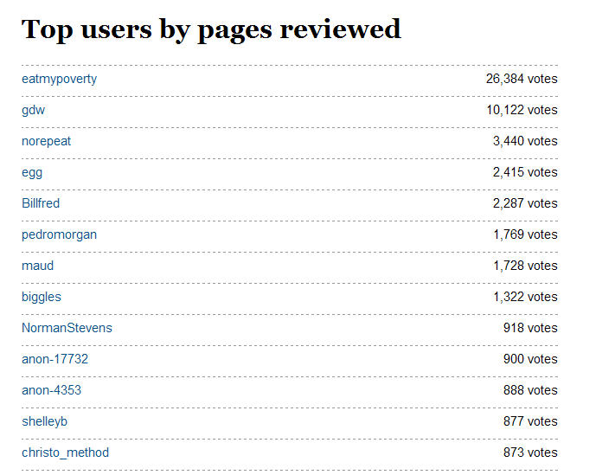

- Tip 8: Give volunteers options and choices
Some volunteers like to be able to choose subjects, and types of work they do, whilst others prefer to be directed to what to do next. Good ideas are to have a ‘pick your work’ and a ‘do the next thing that needs doing’ option. Distributed Proofreaders, the Guardian MP Expenses and Wikipedia all give both choices. In addition Wikipedia and FamilySearchIndexing give options to select projects from different countries, and Wikipedia and Galaxy Zoo also have different language interfaces. Distributed proofreaders, Wikipedia and others also have different tasks for novices and experienced users. All these things extend your volunteer base.

- Tip 9: Let volunteers identify and make themselves visible if they want acknowledgement.
Let users have the option to use/display their real name or a pseudonym, to add a photograph, and to make themselves visible to other volunteers and/or the users of the site. Names may be credited on the site and/or against the item they have worked on.

Fig. 28. Acknowledgement Picture Australia.

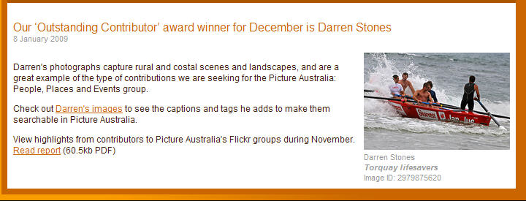

- Tip 10: Give the volunteers an online team/communication environment to build a dynamic, supportive team environment.
There are plenty of online forum and wiki softwares to choose from. Galaxy Zoo have an extensive communication environment with forum, blog, and FAQ.

- Tip 11: Take advantage of transitory and topical events if they help you.
Topics in the news can have a big impact on user activity the primary example being the UK MP’s scandal which led to 20,0000 volunteers signing up and completing work in the first 2 weeks. Take advantage of news events, special occasions, historical anniversaries etc. to get your volunteers to do more work or special targeted bits.

- Tip 12: Treat your ‘super’ volunteers with respect and listen to them carefully.
Remember that your ‘super’ volunteers are usually doing more than half of the entire work so treat them well. Anything they have to say to you should be of interest, especially their feedback on your system and process because they are your heaviest site users. If they recommend something, give it go.

- Tip 13: Keep the site active by addition of new content/work.
Keeping the site current, expanding in data and developing so that your volunteers remain motivated. Crowdsourcing is still quite new and there is no one site that has got it all totally right so volunteers expect development as well as new content to keep them busy.

- Tip 14: Assume volunteers will do it right rather than wrong.
Experience shows that the greater level of freedom and trust you give to volunteers the more they reward you with hard work, loyalty and accuracy. Rather than assuming everything will go wrong and spending valuable time putting systems in place to stop vandalism, assume they will do their best and monitor and help each other. Give them as much freedom as you are able.

6. Power, Potential and Freedom for Libraries

There is a major barrier which is preventing some libraries and archives from seriously considering crowdsourcing and that is loss of power and control. To understand this Kent Fitch, Lead System Architect for the National Library of Australia asked me to consider how the society in which we live has had a changing balance of power over time. In the Pre Enlightenment era the reality was that Kings had divine rights; important decisions were made by a privileged and powerful few; and the people were ruled by Theocracy. In the Post Enlightenment era things changed and there was reason, liberty and democracy. He pointed out how very similar this is to the shift we see now in ‘Information Power’. Pre web, information was produced by a relatively few large and powerful publishers; discovered by metadata hand-crafted by librarians; expensive and centralised. Post web, information is produced by anyone; discovered by full text and bottom-up linking effects; cheap and distributed. What this means is that there is a changing role for libraries and librarians because technology has turned discovery on its head; content can be created by anyone; content can be described by anyone. We are in a time of flux. However libraries still matter and are needed because content still needs to be collected; content still needs to be preserved; content still needs to be described; content still needs to be found. I do not think that Google and Kindle will replace libraries, even though their mission statements may seem on the surface to be similar. “Our vision for Kindle is every book ever printed in any language, all available in less than 60 seconds” (Jeff Bezos, Amazon). “Google's mission is to organize the world's information and make it universally accessible and useful.” Librarians repeatedly hear the question ‘are libraries needed anymore?’ Of course we are – the answer is a definite YES. The Library has a role and commitments that it is unlikely Google and Kindle will commit to long-term, always, or duplicate and these are:

- Long term preservation and access of content (always)
- Not constrained by commercial pressures (always)
- Universal access (always)
- “Free for all” (always)

Kent Fitch says “Technology enables libraries to evolve”. But technology is not the challenge. The challenge is for libraries to be flexible in their thinking and change their long held viewpoints on information power, control and freedom. To embrace change requires changes to workflows, systems, and staffing. Libraries can do this but they tend to move slowly. In the business world it would not be a question of “will we or won’t we?” it would be a question of “this quarter or next quarter?” for their survival. Crowdsourcing is a good example of a major change for a library, and a perceived change in balance and power from the libraries to the people.

However change is afoot. In August 2009 Wikimedia Australia organised an event called GLAM-Wiki in Canberra, the first of its type in the world. The time seemed right for representatives of the GLAM sector (Galleries, Libraries, Archives and Museums) to get together with the digital volunteer community that is Wikimedia. The event was called ‘Finding the common ground’ and the theme was that users are collaborators, so how can we all work together to achieve our shared aim of access and use of resources? 170 GLAM organisations attended, and discussion between the GLAM sector and Wikimedians was exciting and positive. The outcomes of the day formed a GLAM-Wiki Recommendations document, which is now being considered by the Government, the GLAM sector and Wikimedians in Australia. One of the messages the Wikimedians delivered was that they want to help libraries in crowdsourcing activities. There is already a strong digital volunteer community that is ready and willing to help good causes. If we can change our thinking on power and instead see potential we would be in a much better place. It is no longer about power.

A well used quote by Harriet Rubin says “Freedom is actually a bigger game than power. Power is about what you can control. Freedom is about what you can unleash”.

Crowdsourcing with a shared common goal is a new phenomenon and has big potential for libraries. Libraries are already proficient in the first step in crowdsourcing: social engagement on an individual level. Social engagement has happened for years in libraries. In the ‘pre- digital library days’ a user did not expect to go to a library and have a simple information transaction. They wanted the information but they also wanted to discuss with the librarian (or any other user) what they thought of the latest novel they had just read, the results of their research, what else they know about steam locomotives that was not in the book they just read, the error they just found in your card catalogue. On the books return desk they tried to sneak back text books that had pencil or worse pen or highlighter underlinings and annotations, without the librarian noticing. If they were noticed they would be fined, or worse banned from borrowing books again! They formally wrote the librarian letters of complaint or compliment about their services and the librarian replied on letter headed paper. When we first started delivering digital resources all these social interactions were taken away from users and they simply got an information transaction by downloading content. It has taken us a while to realise that users still want more than a simple information transaction and they want the same and more social interactions than they had in the ‘pre-digital library’ days. In our digital library world they want to: review books, share information, add value to our data by adding their own content, add comments and annotations and ‘digital post its’ to e-books, correct our data errors, and converse with other users. And now they are telling us they can do even more, they can organise themselves to work together to achieve big goals for libraries and make our information even more accessible, accurate and interesting. Why are we not snapping up this great offer immediately?

The potential is huge. Libraries have such a massive user base and both broad and specific subject areas that have wide appeal. We could get hundreds of thousands of volunteers if we really publicized and appealed for help. Anyone with an internet connection is a potential volunteer so in Australia that is 10 million people at least. We could apply text correction and transcription across all our full-text materials – books, journals, newspapers, manuscripts, archives. Instead of each library appealing for their own volunteers there could be a centralized global pool of volunteers and projects for the entire GLAM sector.

Digital users do not care about institution walls. We have worked hard to break down the walls or make them invisible to users when they are searching digital collections. Providing federated searches or national digital aggregated collections is now the norm with examples like Picture Australia, Matapihi, Digital NZ, and Trove being exemplar. But we should break down these walls in crowdsourcing projects as well e.g. someone wants to improve resources on shipping lists – they should be able to come to a central portal to find all the projects and countries involving shipping lists instead of having to discover and find for themselves that there are shipping lists which can be corrected in 3 different projects: Australian Newspapers, Mariners and Ships in Australian Waters, and FamilySearchIndexing.

Libraries and archives will never have the resources to fully do what they or the users want so crowdsourcing is an opportunity that should be grabbed and taken very seriously. Ironically Governments in the UK and Australia are now taking social engagement very seriously and looking at developing policies for this and the utilisation of web 2.0 technologies into their government departments, including libraries. The Australian Government 2.0 Taskforce is in the final stages of preparing its recommendations. But libraries do not need to wait for taskforce instructions to engage with users this has been their ‘modus operandus’ for years, and is seen by many librarians simply as excellent customer service.

So what do libraries need to think about in relation to crowdsourcing? Here are some ideas:

- How can we build back social engagement into all our activities as normal business?
- What do we want help with? (Indexing, transcription, creation of content)
- Why do we want this help? (To improve data quality, to socially engage, to get new content, to stay relevant, etc).
- Should we build partnerships with existing crowdsourcing non-profit making organisations to share use of existing volunteers, especially Distributed Proofreaders and Wikipedia?
- Can we build our own sites that incorporate the crowdsourcing tips using the open source software developed by others? (Easy, quick, rewards, acknowledge, communicate)
- Is it possible to work towards establishing a global pool of volunteers and a crowdsourcing portal that has no country or organisation boundaries?
- Can libraries market effectively in the online environment to appeal for volunteers?
- How should we structure the user generated content behind the scenes (add into our own data, or keep in separate locations and layers)?
- When can we build the changes and activity into our strategic plans?
- How we can change the ‘power’ thinking of strategic staff to ‘freedom and potential’ thinking to make this happen on a mass scale?
- When are we going to start this?

At the National Library of Australia the new Strategic Plan for the Innovation and Resource Sharing Division now takes into account significant changes in user expectations, technology, and the wider environment, including “…the expectation of some users that they will not be passive receivers of information, but rather contributors and participants in information services, and thus will be able to share ideas and information”. The Australian Newspapers service has illustrated how dramatically the digital environment may change the user/library dynamic. The Library has acknowledged this in its forward planning and other libraries should do the same.

7. Conclusion

The Australian Newspapers experience of crowdsourcing is not unique, but matches those of other prior relevant projects. If the tips/lessons learnt from the projects are applied any crowdsourcing project that is ‘for the common good’ and initiated by a non-profit making organisation such as a library is likely to be successful. If the public are given a high level of trust and responsibility they will respond with loyalty and commitment. There is huge potential for libraries to harness digital volunteers. However we need to give up the power game and look to freedom instead. “Freedom is actually a bigger game than power. Power is about what you can control. Freedom is about what you can unleash” (Harriet Rubin). And we need to be courageous about this. “If you have courage then you will influence people based on your passionate convictions” (John C. Maxwell). Do we dare give users something greater than power – freedom? Will other libraries follow and build on the example the National Library of Australia has set? I hope so.

8. References and Footnotes

Statistical information and verbal quotes from:
Kent Fitch (Lead System Architect, National Library of Australia)
Juliet Sutherland (Manager, Distributed Proofreaders)
Liam Wyatt (VP Wikipedia Australia)
Erik Moeller (Deputy Director, Wikimedia Foundation)
Mark Kelly (FamilySearch Support Manager Australia/PNG, FamilySearchIndexing).
Fiona Hooton (Manager, Picture Australia)
Rose Holley (Manager, Australian Newspapers)
Simon Willison (System Architect, Guardian MP’s expenses)

Url’s of crowdsourcing site examples:
Australian Newspapers: http://ndpbeta.nla.gov.au
Australian Newspapers Digitisation Program website: http://nla.gov.au/ndp
Picture Australia: http://www.pictureaustralia.org/
FamilySearchIndexing http://www.familysearchindexing.org/home.jsf
Distributed Proofreaders: http://www.pgdp.net/c
Wikipedia: http://www.wikipedia.org/
UK MP’s Expenses: http://mps-expenses.guardian.co.uk/
Galaxy Zoo: http://www.galaxyzoo.org/
BBC WorldWar2 Peoples War: http://www.bbc.co.uk/ww2peopleswar
Mariners and Ships in Australian Waters: http://mariners.records.nsw.gov.au/
FreeUKGen: http://freeukgen.rootsweb.com/
WorldGenWebArchives: http://www.worldgenweb.org/index.php/worldgenweb-archives

Footnotes:

The PowerPoint presentation of this paper will be made available on the E-LIS International Library Repository, SlideShare and the PRDLA website.
Wikipedia (2009) Article on crowdsourcing: http://en.wikipedia.org/wiki/Crowdsourcing viewed August 2009.
Sharky, Clay (2009) Here Comes Everybody: How Change Happens When People Come Together, Penguin Books, ISBN 9780141030623.
Holley, Rose. (2009) Many Hands Make Light Work: Public Collaborative OCR Text Correction in Australian Historic Newspapers, National Library of Australia, ISBN 9780642276940 http://www.nla.gov.au/ndp/project_details/documents/ANDP_ManyHands.pdf
Hooton, Fiona. (2006) Picture Australia and the flickr effect. Gateways, number 80, April 2006. http://www.nla.gov.au/pub/gateways/issues/80/story01.html
Lih, Andrew (2009) The Wikipedia Revolution: How a bunch of nobodies created the world’s greatest encyclopedia, Aurum Press Ltd, ISBN 9781845134730
Voss, Jakob (2005). Metadata with Personendata and beyond. Wikimania 2005 paper. http://meta.wikimedia.org/wiki/Transwiki:Wikimania05/Paper-JV2
Danowski, Patrick (2007). Library 2.0 and User Generated Content: What can the users do for us? Staatsbibliothek zu Berlin. 73rd IFLA Conference Paper, 19-23 August 2007, Durban, South Africa. http://ifla.queenslibrary.org/IV/ifla73/papers/113-Danowski-en.pdf
Anderson, Michael (2009) Four crowdsourcing lessons from the Guardian’s (spectacular) expenses-scandal experiment. June 23 2009. http://www.niemanlab.org/2009/06/four-crowdsourcing-lessons-from-the-guardians-spectacular-expenses-scandal-experiment/
Wikipedia (2009) Article on Galaxy Zoo: http://en.wikipedia.org/wiki/Galaxy_Zoo viewed October 2009.
BBC (2009) WW2 People’s War: Project History: How the site worked: User Journey. http://www.bbc.co.uk/ww2peopleswar/about/project_07.shtml#personalpages. Viewed August 2009.
Wikipedia (2009) Wikipedia Statistics: http://en.wikipedia.org/wiki/Wikipedia:Statistics. Viewed October 2009.
Jorgensen, John (2007). 21 Proven Motivation Tactics. Published online in Pick the Brain, August 23 2007. http://www.pickthebrain.com/blog/21-proven-motivation-tactics/
Wikimedia (2009). GLAM-Wiki event ‘Finding the Common Ground’ held 6-7 August, Canberra, Australia: http://wikimedia.org.au/wiki/GLAM-WIKI
Wikimedia (2009). GLAM-Wiki Recommendations, from the GLAM-Wiki event ‘Finding the Common Ground’ held 6-7 August 2009: http://meta.wikimedia.org/wiki/GLAM-WIKI_Recommendations
(2009) Australian Government 2.0 Taskforce website, blog, draft report: http://gov2.net.au/

